## Developing a Power Apps Portal

**Lab Time**: 60 minutes

**Lab Folder**: C:\Student\Modules\08_PowerAppsPortals\Lab

**Lab Overview**: This lab covers how work with a Power Apps portal.

### Exercise 1: Add Content to the Portal using Power Apps Portal Studio

In this exercise, you will use **Portal App Portal Studio** to add and modify content in the portal.

1. Open your Power Apps portal in Power Apps Portal Studio.
   1. Click the **Apps** link in the left navigation to see the list of apps for **My Dev Environment**.
   2. Drop down the ellipse menu for your portal.

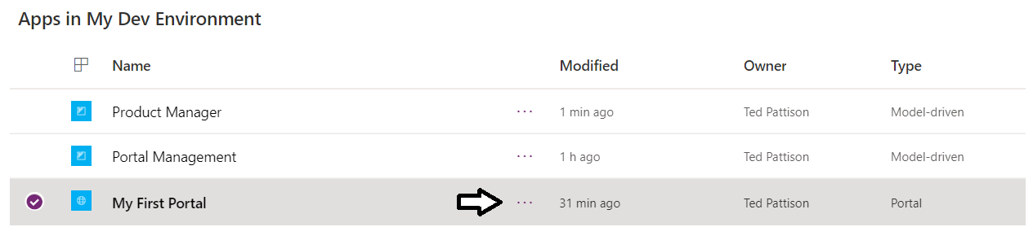

* 1. Select the **Edit** command on the portal ellipse menu.

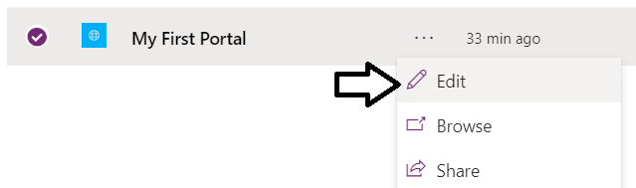

* 1. The portal should open up in Power Apps Portal Studio and display the portal **Home** page in edit mode.

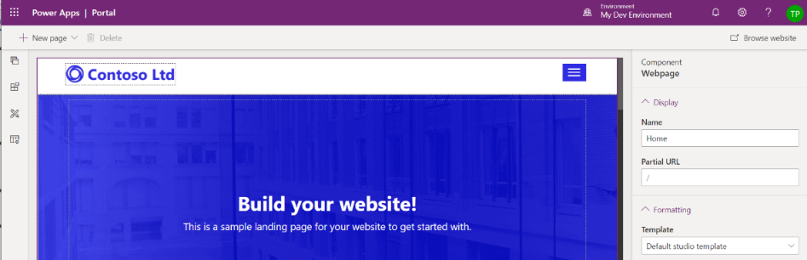

1. Replace the logo image in the portal site header
   1. Using the mouse, select the **Contoso Ltd** logo image in the page header.

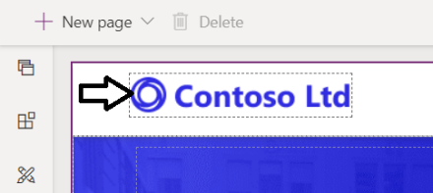

* 1. With the log image select, inspect the image file name **Logo.png** on the right in the **Component Image** properties pane.

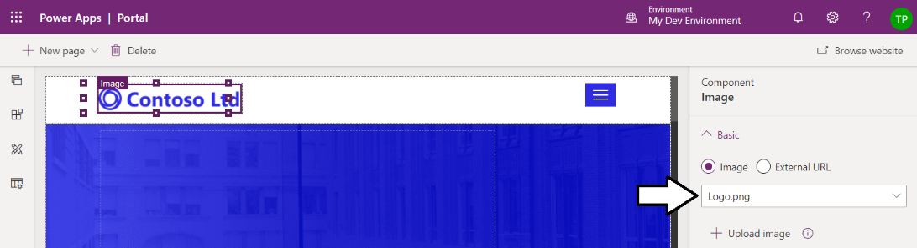

* 1. Click the **Upload image** link in the **Component Image** properties pane.

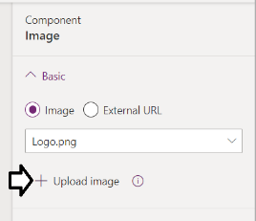

* 1. Upload the image file named **wingtip_logo.png** from inside the **Student** folder at the following path.

C:\Student\Modules\08_PowerAppsPortals\Lab\wingtip_logo.png

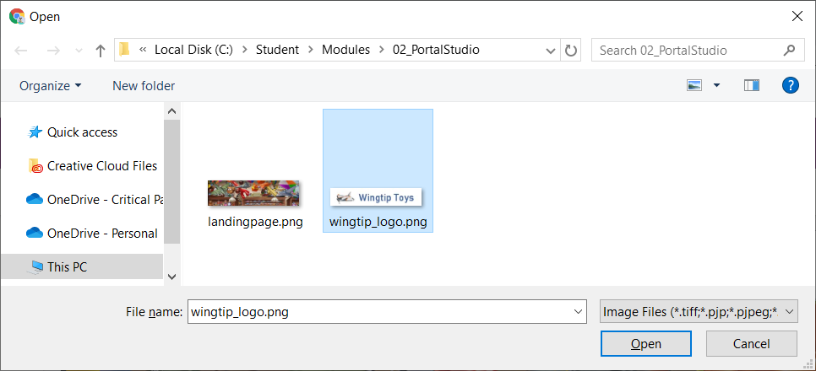

* 1. You should see that the logo image in the page header has been updated with the **Wingtip Toys** logo.

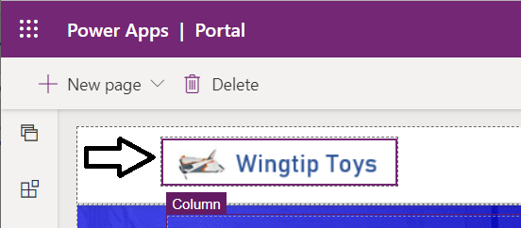

1. Modify the text on the portal home page.
   1. Select the **Build your website!** text on the Home page.

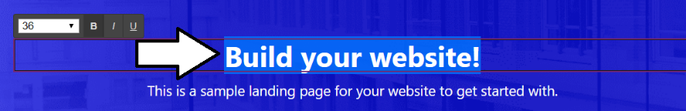

* 1. Replace the text the **Build your website!** text with something different such as **Awaken Your Inner Child**.

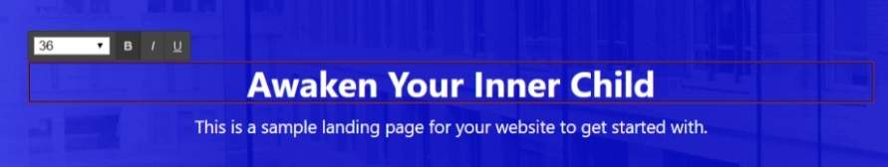

* 1. Delete the second line of text underneath the text you updated in the previous step.

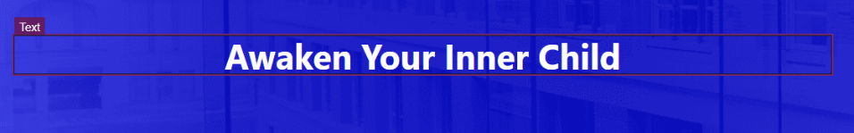

* 1. Select the text you added and then drop down the font size editor control.

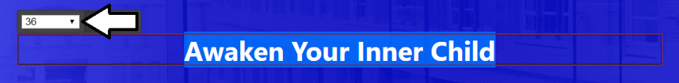

* 1. Set the font size to **48**.

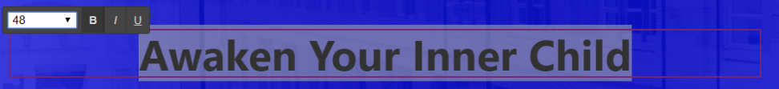

* 1. Change the **Font color** to **#ffff00** which is the hex code for the color yellow.

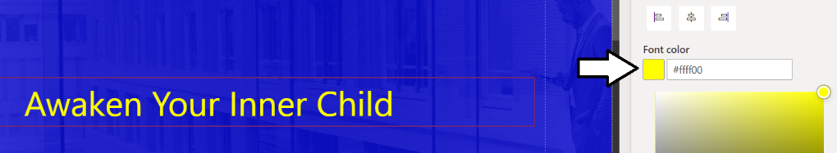

* 1. On the left, click the image with blue background and inspect the image file name in the **Component Section** properties pane.

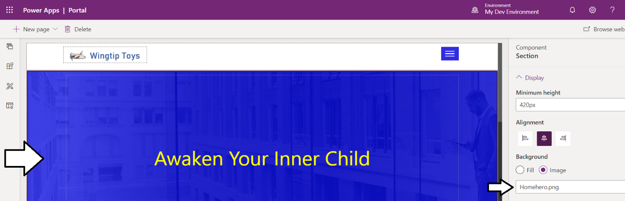

* 1. Click the **Upload image** link to replace **Homehero.png**.

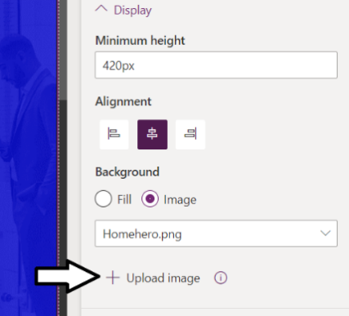

* 1. Select the image file named **landingpage.png** from inside the **Student** folder at the following location.

C:\Student\Modules\08_PowerAppsPortals\Labs\landingpage.png

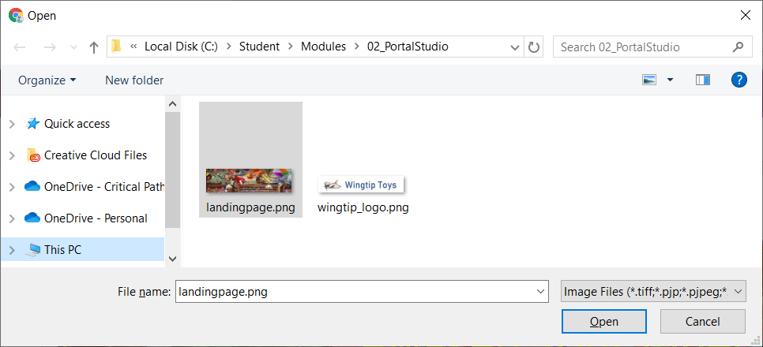

* 1. You should now see the image background shown in the following screenshot.
  2. Yu should be able to see in the **Minimum height** property of **420px** displayed in the **Component Section** properties pane.

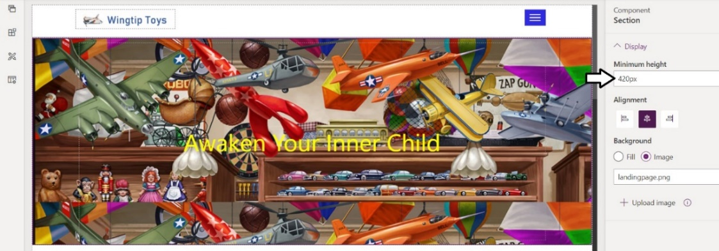

* 1. Update the **Minimum height** property for the section to **200px**

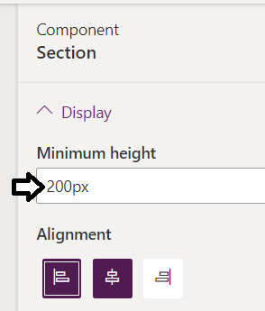

* 1. The section with the background image should now be half the height as it was before.

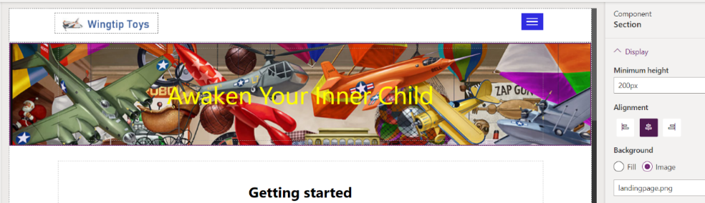

1. Modify the remaining Home page content.
   1. Move down to the next section and change the **Getting started** text the text shown in the following screenshot.

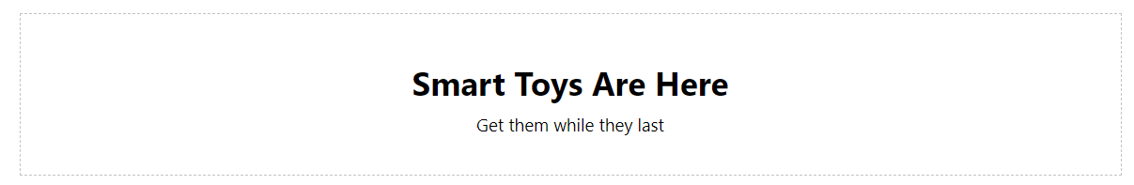

* 1. Move down the Home page. Select and delete the next section with the three columns.

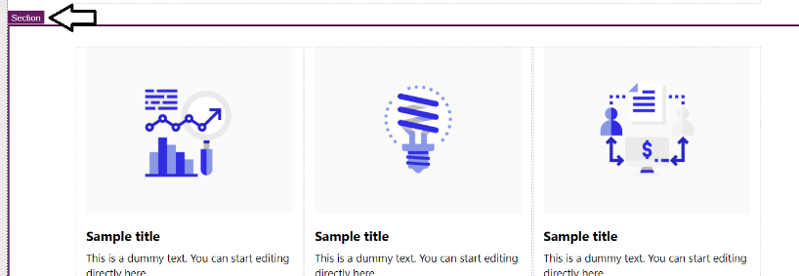

* 1. Move down the Home page and delete the next section with the **Grow your business** text as well.

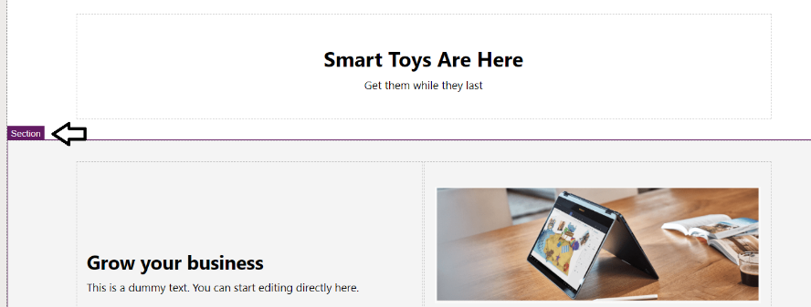

* 1. Move down in the **Home** page to the blue section and modify the text as shown in the following screenshot.

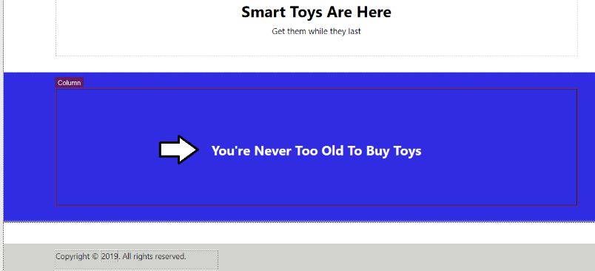

* 1. Set the **Minimum height** of the blue section to **120px**.

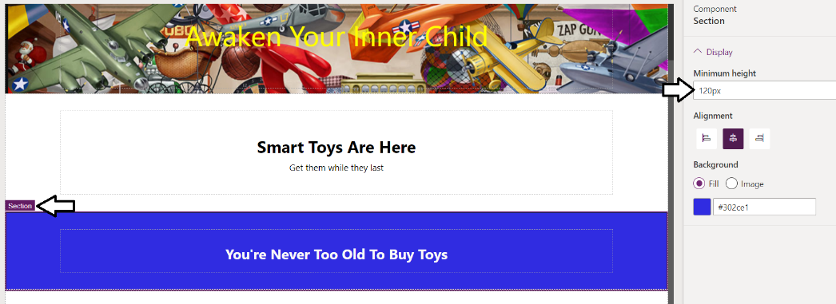

1. Launch the portal to test what your changes look like to a website visitor.
   1. Click the **Browse website** button to clear the cache and launch the portal in a new browser tab.

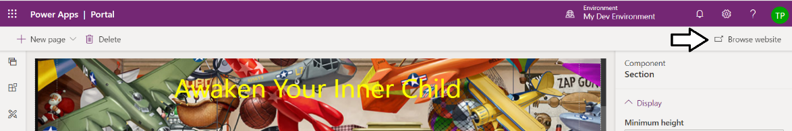

* 1. The portal should launch and display the **Home** page in a new browser tab.

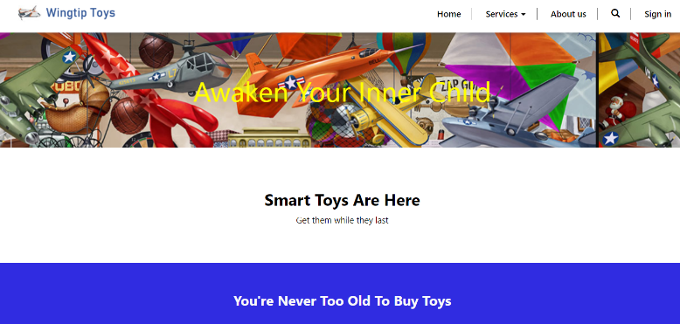

* 1. Click the **About us** link on the top navigation menu to navigate to the **About us** page.



* 1. The portal should display the **About us** page as shown in the following screenshot.

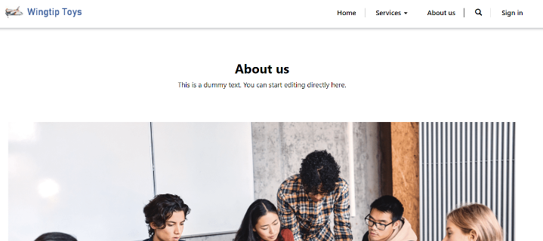

* 1. Close the current browser tab and move back to the tab with Power Apps Portal Studio.

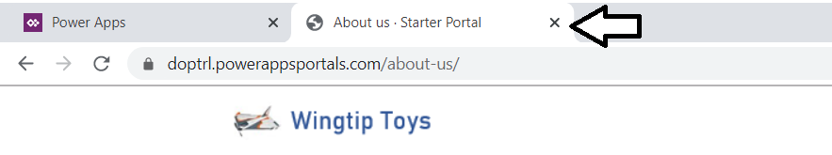

* 1. You should now be back at the **Home** page of the portal in Power Apps Portal Studio.

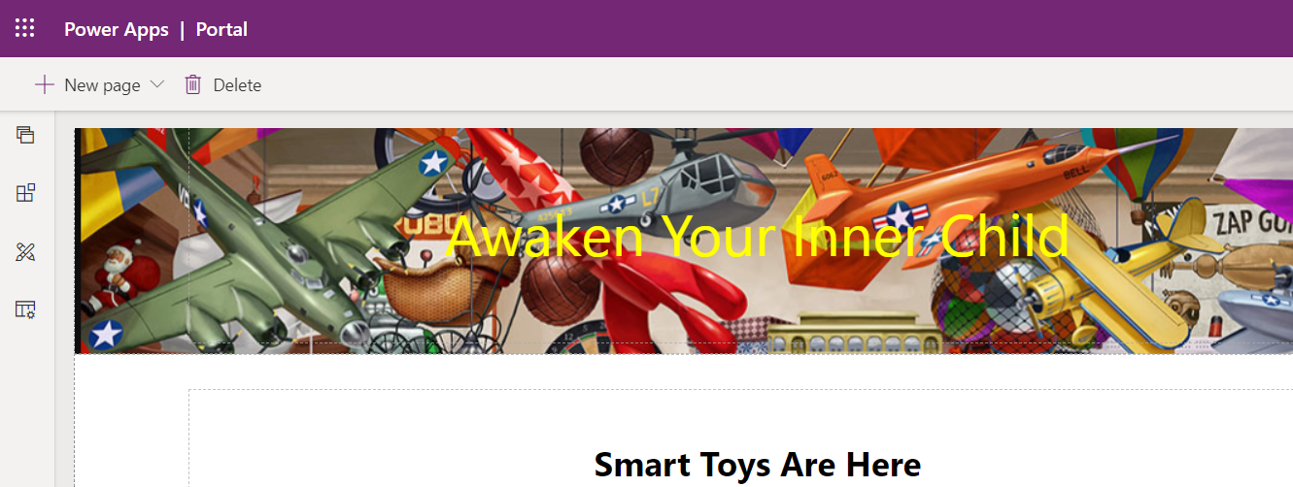

1. Modify the content in the **About us** page.
   1. Click the **Pages** icon button to expand the **Pages** flyout menu.

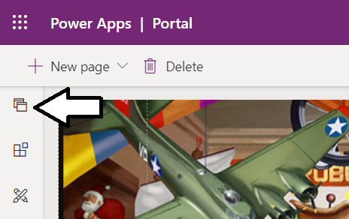

* 1. Click the **About us** link to navigate to the **About us** page.

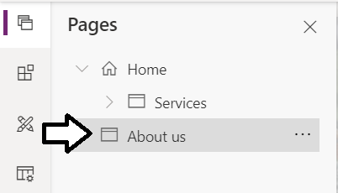

* 1. You should now see the **About us** page which is configured to use the page template named **Default studio template**.

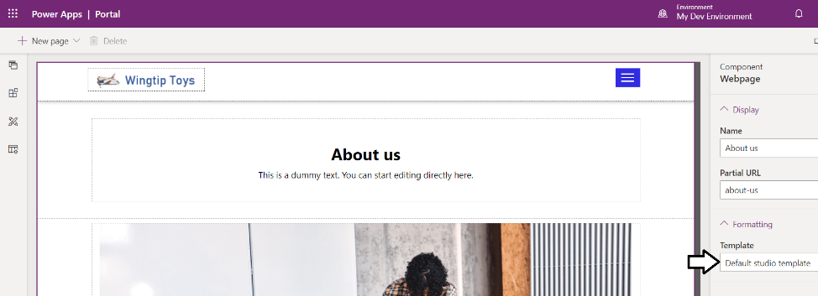

1. Change the page template for the **About us** page.
   1. Drop down to **Template** menu to see the available set of templates.

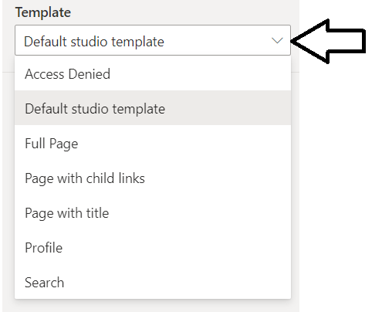

* 1. Select the **Full Page** template and then wait a few seconds while the page refreshes and renders using the new template.

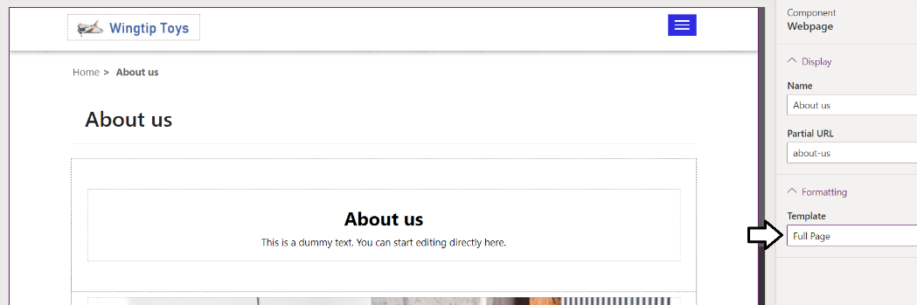

1. Modify the text on the **About us** page.
   1. Modify the text in the top section to match the following screenshot.

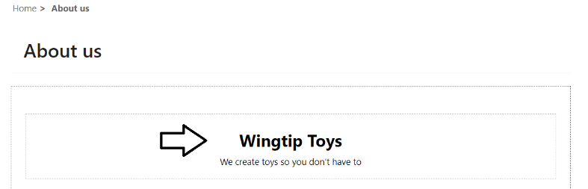

* 1. Modify the **Minimum height** of this section to **64px**.

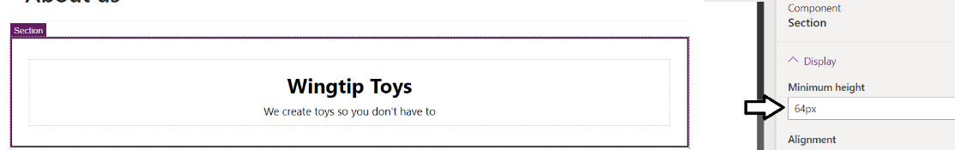

* 1. Select the image and inspect the name of he image (**AboutUs.png**) in the **Component Image** properties pane.

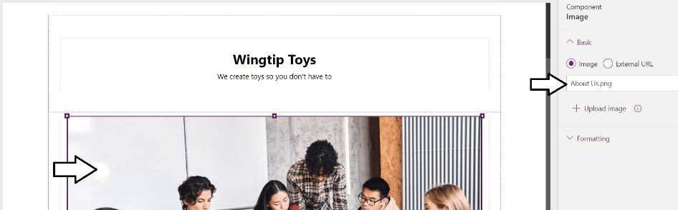

* 1. Update the image to use the image file uploaded in an earlier step named **landingpage.png**.

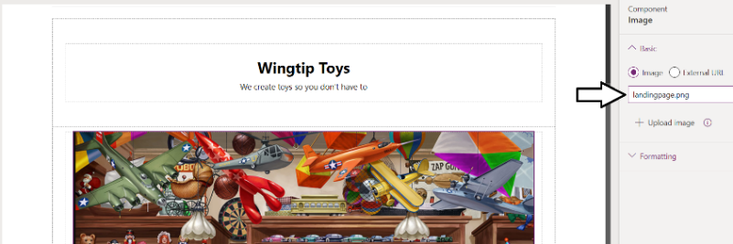

1. Browse the website to test the changes you have made to the **About us** page.
   1. Click the **Browse website** button to clear the cache and launch the portal in a new browser tab.

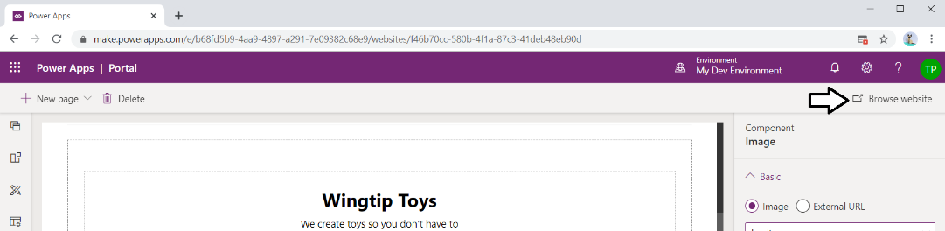

* 1. Your **About us** page should match the following screenshot.

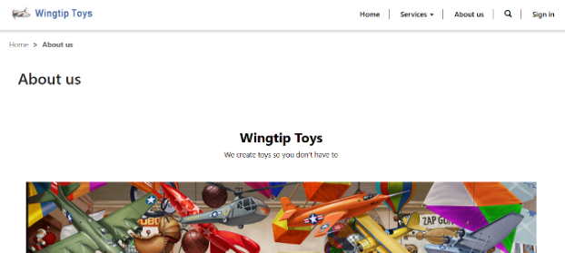

* 1. Drop down the **Services** menu to see the menu commands inside.

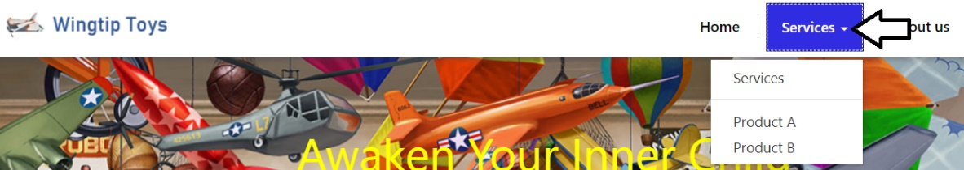

* 1. Close the current browser tab and move back to the browser tab with the portal in Power Apps Portal Studio.

1. Modify the **Services** page.
   1. Click the **Pages** icon button to expand the **Pages** flyout menu.
   2. Click the **Services** link to navigate to the **Services** page.

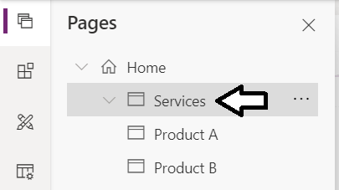

* 1. You should now see the **Services** page in Power Apps Portal Studio as shown in the following screenshot.

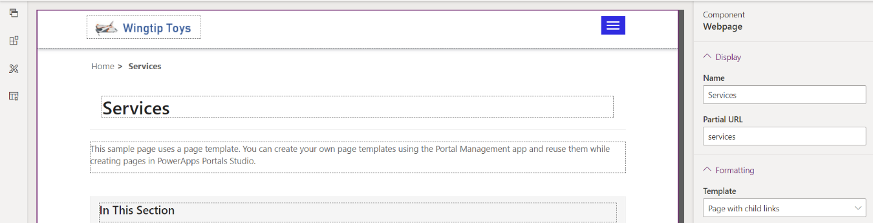

* 1. In the **Components Webpage** properties pane, update the **Name** property to **Products**. and press Tab to exit the textbox.

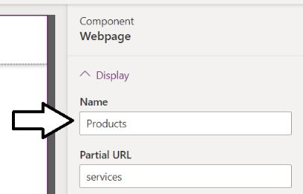

* 1. Once the change to the **Name** property has been saved, the page should display the new name of **Products**.

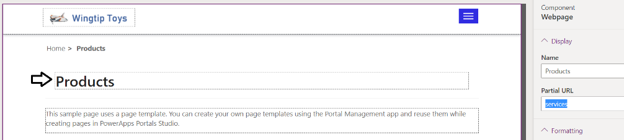

* 1. Update the **Partial URL** property to products and press Tab to exit the textbox.

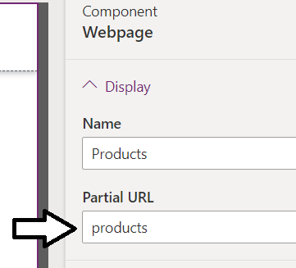

* 1. Update the two section of text on the **Products** page as shown in the following screenshot.

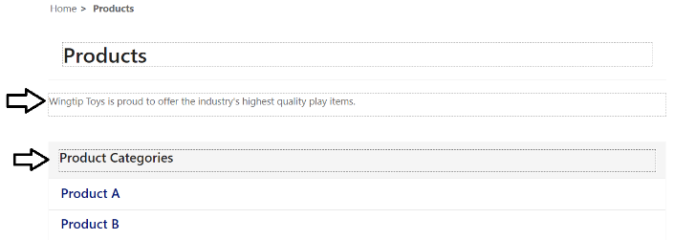

1. Update the child pages of the **Products** page.
   1. Navigate to the page named **Product A**.

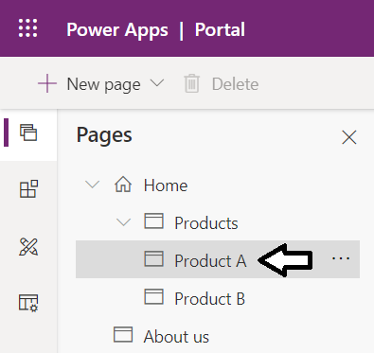

* 1. Inspect the Component Webpage properties pane to see the page **Name** and **Partial URL**

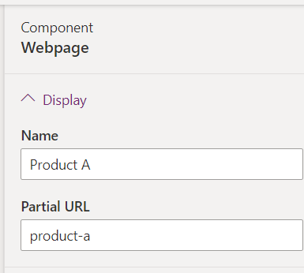

* 1. Update the **Name** to **Action Figures** and the **Partial URL** to **action-figures**.

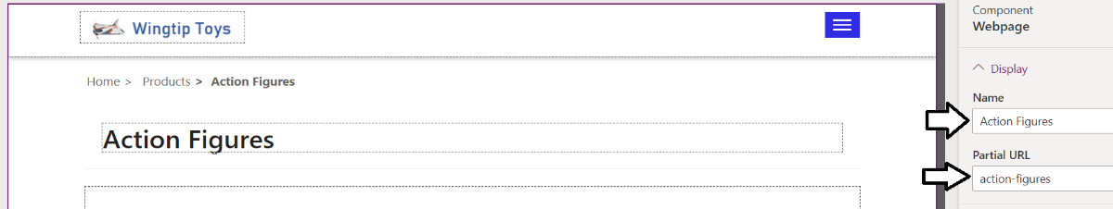

* 1. Navigate to the page named **Product B**.

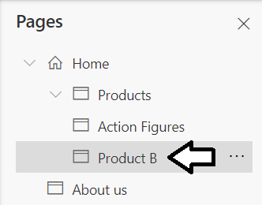

* 1. Update the webpage **Name** to **Arts and Crafts**
  2. Update the **Partial URL** to **arts-and-crafts**.

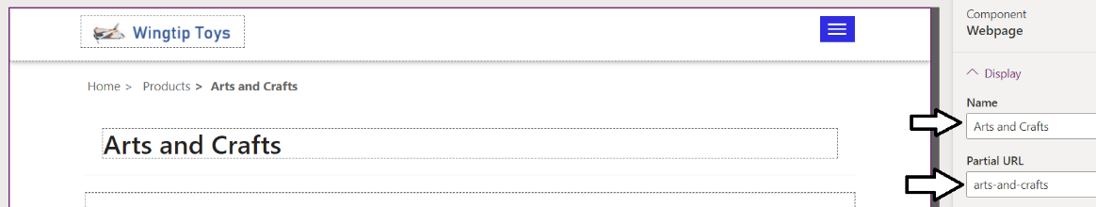

1. Add a new child page underneath the **Products** page.
   1. From the **Pages flyout** menu, select the **Add a child page** command using the ellipse menu of the **Products** page.

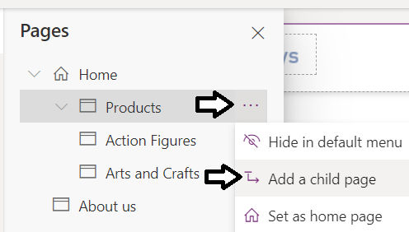

* 1. You should now see a new page with a default name of **New page (1)**.

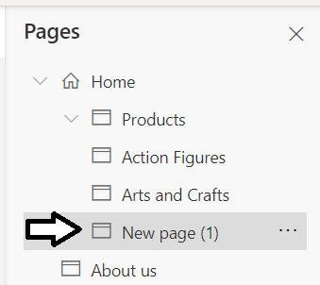

* 1. The **Component Webpage** properties pane should initially appear with the settings shown in the following screenshot.

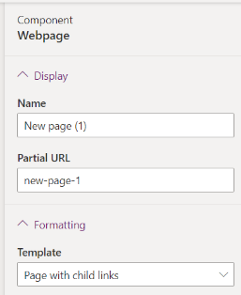

* 1. Change the **Template** setting for the new page to the template named **Page with title**.

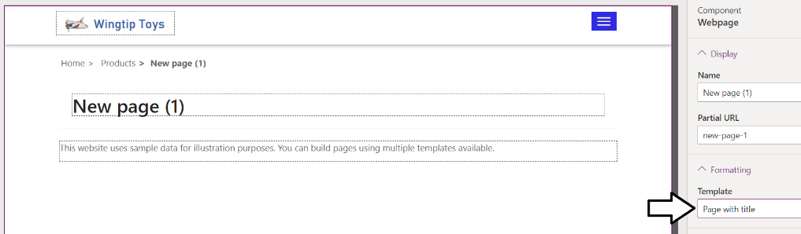

* 1. Update the webpage **Name** to **Remote Control**.
  2. Update the **Partial URL** to **remote-control**.

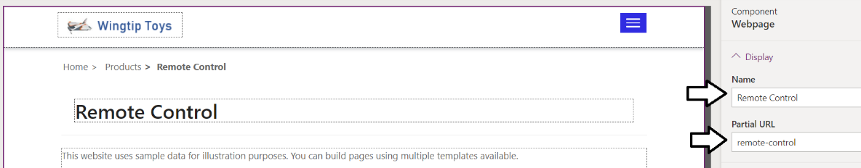

1. Browse the website to test the changes you have made to the **Product** page and its children.
   1. Click the **Browse website** button to clear the cache and launch the portal in a new browser tab.

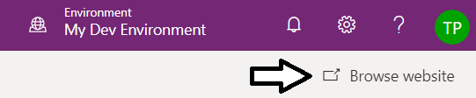

* 1. Once the portal launches, use the **Products** drop down menu to navigate to it child pages.

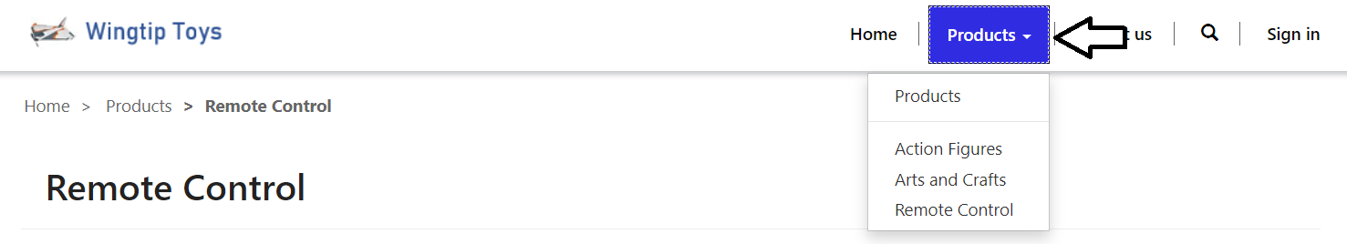

* 1. You should observe that each child page display a breadcrumb menu with **Home > Products > Remote Control**.

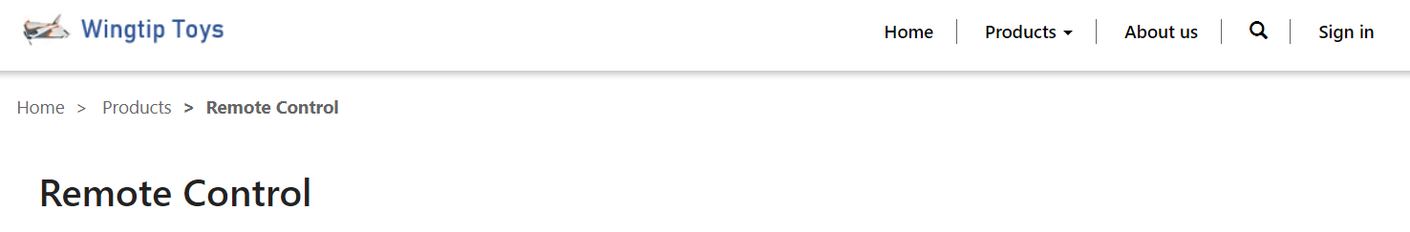

You're now done working with Power Apps Portal Studio. In the next exercise, you will begin working with the Portal Management app.

### Exercise 2: Configuring a Power Apps Portal using the Portal Management App

In this exercise, you will use **Portal App Portal Studio** to add and modify content in the portal.

1. Make sure you leave Power Apps Portal Studio running in its own separate browser tab.
   1. In later steps, you will be asked to return to Power Apps Portal Studio so you can click the **Browse website** button for testing.



1. Launch the model-driven app named **Portal Management**.
   1. Open a new browser tab and navigate to **My Dev Environment** in the Power Apps make portal.
   2. Click the **Apps** link in the left navigation to see the list of apps for **My Dev Environment**.
   3. Click on **Portal Management** to launch this model-driven app.

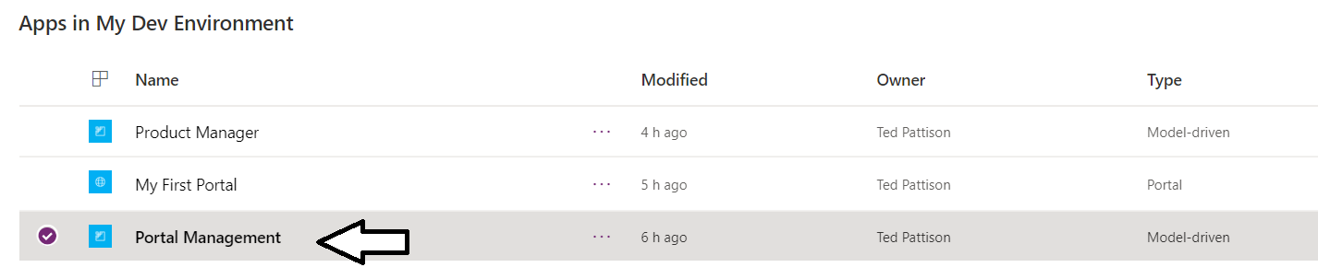

* 1. When the app starts, you should see the Websites list which contains a single website named **Starter Portal**.
  2. Click on **Starter Portal** to display the record for this website.

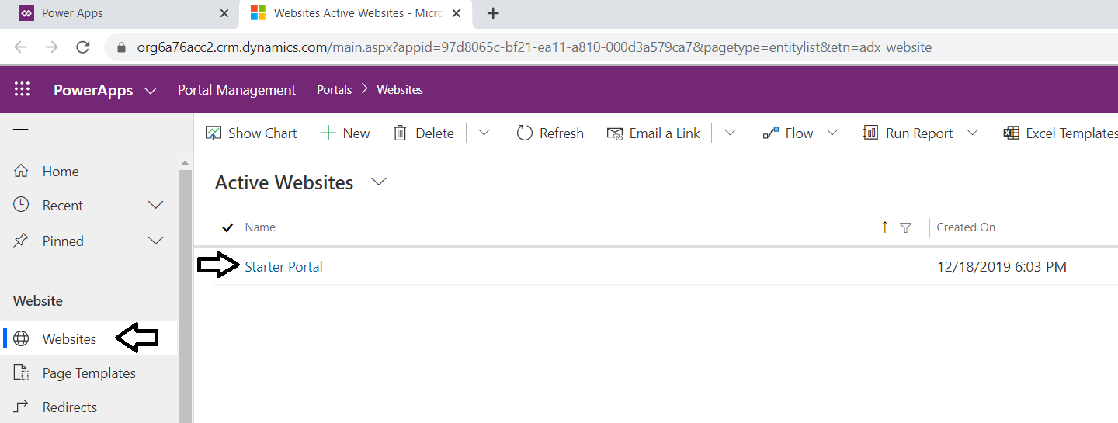

* 1. The website name has a default value of **Starter Portal**.

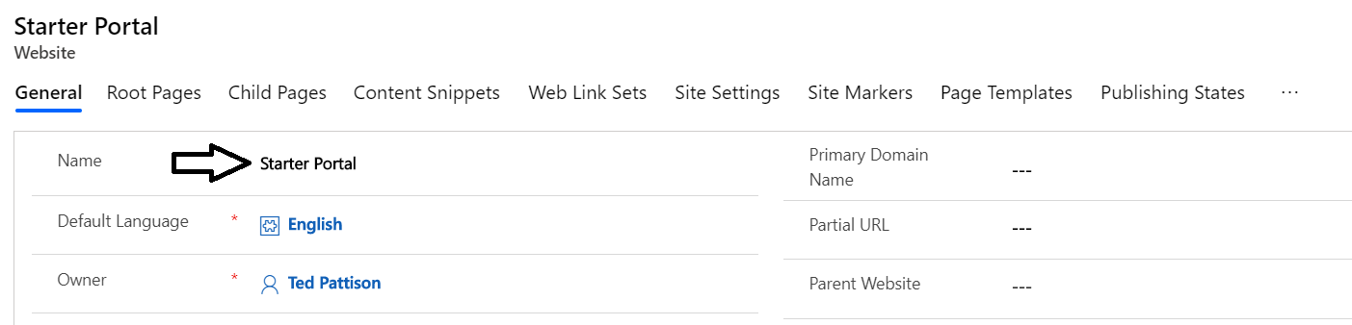

* 1. Update the website name to **Wingtip Toys Portal** and then click the **Save** button in the lower right corner.

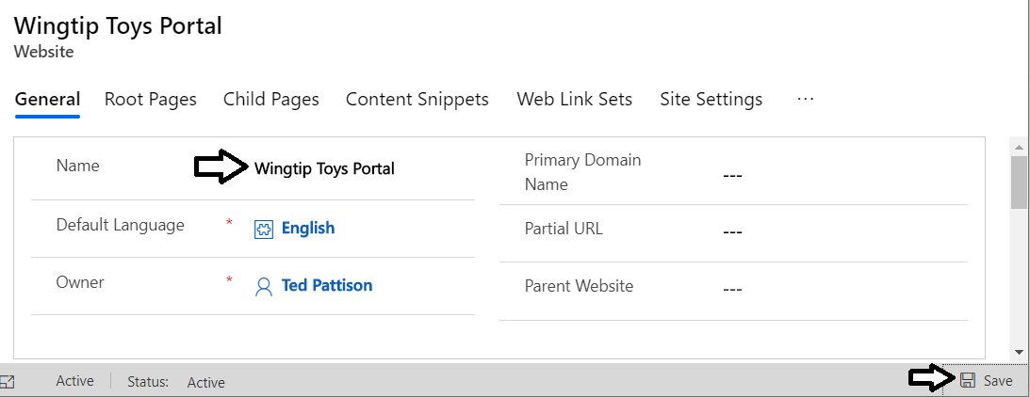

1. Update the snippet named **Browser Title Suffix**.
   1. Select **Content Snippets** from the left navigation.

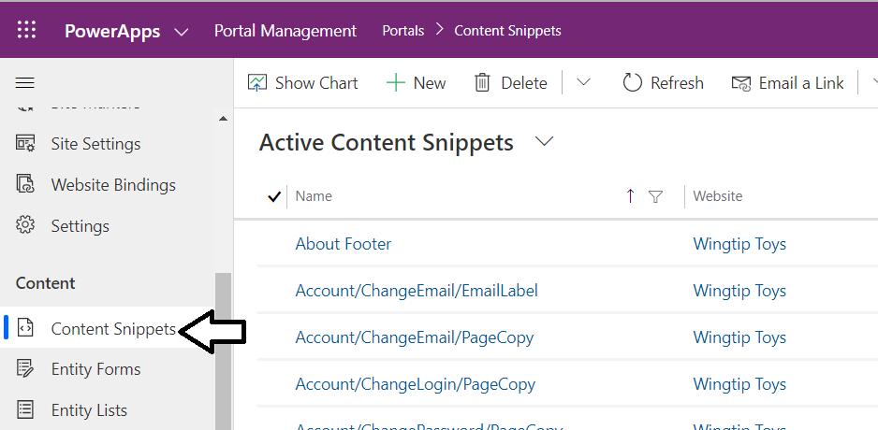

* 1. Scroll down the Active Content Snippets list and locate the **Browser Title Suffix**.
  2. Click on the **Browser Title Suffix** snippet to open its record.

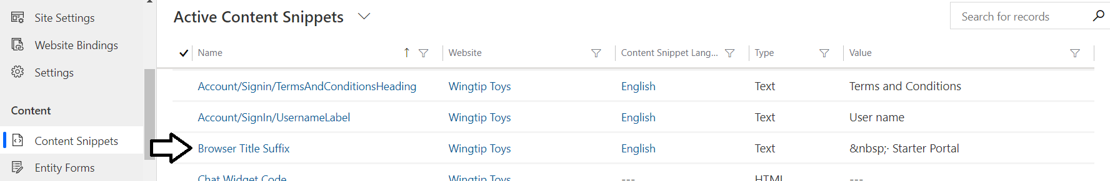

* 1. Locate the textbox with the snippet **Value** property.

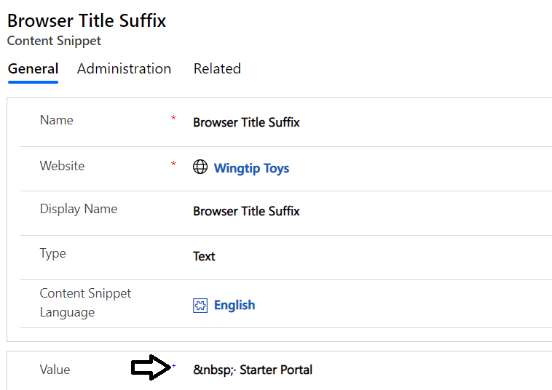

* 1. Replace the text "Starter Portal" with "Wingtip Toys" and then click **Save**.

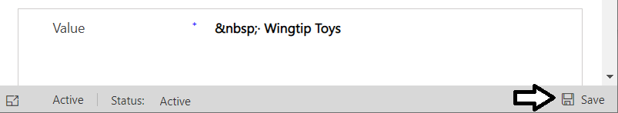

1. Test your changes to the browser title.
   1. Return to the browser tab running Power Apps Portal Studio.
   2. Click the **Browse website** button to clear the cache and launch the portal in a new browser tab.



* 1. Once the portal launches with a cleared cache, you should see the title **Wingtip Toys** in the browser tab.

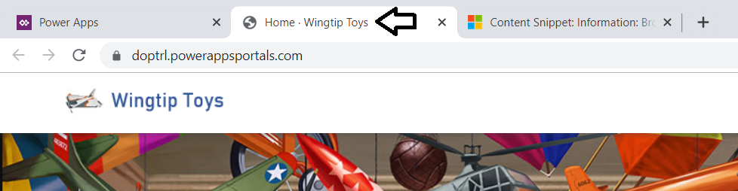

You are now finished with this lab.